MINISTRY OF EDUCATION AND TRAINING

Ho Chi Minh City University of Technology and Education

INTERNATIONAL FACULTY

----------



PROJECT REPORT

SUBJECT: MOBILE PROGRAMMING

***TOPIC: MUSIC APPLICATON***

*Lecturer:* Trương Thị Ngọc Phương

|  |  |  |
| --- | --- | --- |
| No | *Members:* | ID |
| 1 | Đỗ Huỳnh Bảo Đăng | 21110764 |
| 2 | Nguyễn Duy Mạnh | 21110780 |
| 3 | Ngô Phạm Quang Vinh | 21110112 |

HCM, 2024

**INSTRUCTOR'S COMMENTS**

Mark………………………

# **PROLOGUE**

Firstly, we would like to express our gratitude to PhD. Trương Thị Ngọc Phương for his whole-hearted instructions that helped us finish our final project for the Moblie Programming course. Thanks to the knowledge the professor has provided us, we were able to firmly grasp the basic knowledge and foundation for building project using Firebase and Java. And through this project, our group would like to present the topic: Building a muisic application. During the process of executing this project, it will be hard to avoid mistakes. Because of that, we would love to get the professor’s suggestion on improving our work so it would be more functional and complete. We wish you good health and the best of luck pursuing the path of teaching.

Finally, we would like to thank all the teachers and classmates who studied with us on this course and offered us support while we carried out our final project.

**CONTENTS**

**PROLOGUE** 3

**CHAPTER 1. INVESTIGATE THE CURRENT BUSINESS STATUS** 5

**1.1** **Current status:** 5

**1.2 Request:** 6

**CHAPTER 2. LISTS OF REQUIREMENTS FOR THE SOFTWARE** 7

**2.1. Functional business requirements** 7

**2.2 Functional system requirements** 8

**2.3. Non-functional requirements** 10

**2.4 Use- case diagram** 11

**Chapter 3 Modeling** 12

**3.1 Actor** 12

**3.2 Use Case Description** 13

**CHAPTER 4: DATABASE DESIGN** 22

**4.1 Class diagram design** 22

# **CHAPTER 1. INVESTIGATE THE CURRENT BUSINESS STATUS**

## **Current status:**

## **1.2 Request:**

# **CHAPTER 2. LISTS OF REQUIREMENTS FOR THE SOFTWARE**

## **2.1. Functional business requirements**

Division: **Admin Management**

| No. | Function | Type | Constraint/ Formula code | Form code | Note |
| --- | --- | --- | --- | --- | --- |
| 1 | User Management | Storage |  |  | View, edit, delete user accounts |
| 2 |  |  |  |  |  |
| 3 |  |  |  |  |  |

**Division: User Management**

| No. | Function | Type | Constraint/ Formula code | Form code | Note |
| --- | --- | --- | --- | --- | --- |
| 1 | Search | Searching |  |  |  |
| 2 |  |  |  |  |  |

## **2.2 Functional system requirements**

## **2.3. Non-functional requirements**

## **2.4 Use- case diagram**

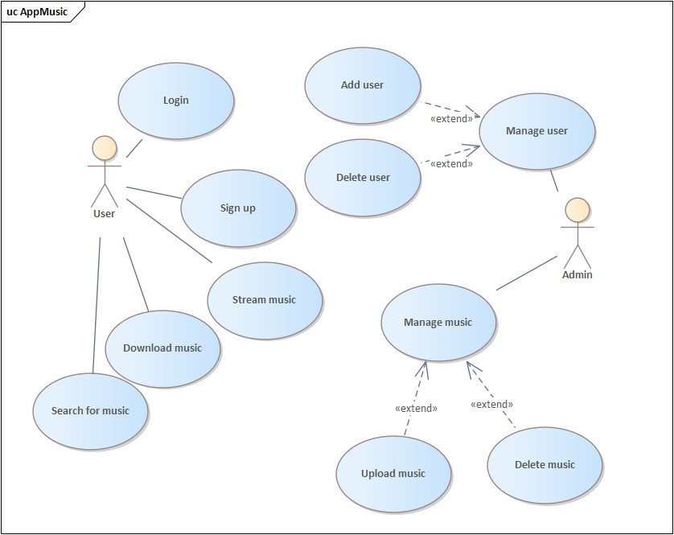

# **Chapter 3 Modeling**

## **3.1 Actor**

|  |  |  |
| --- | --- | --- |
| **Actor** | **Role** | **Description** |
| 1 | Admin | Is the person who manages the entire website operation, from managing products, orders, and customers to billing, shipping, and website maintenance. The task of the admin is to ensure the smoothness and efficiency of the system, as well as business development by meeting the needs of customers and the market. |
| 2 | User |  |

## **3.2 Use Case Description**

|  |  |
| --- | --- |
| Use Case Login | |
| **Describe** | Allow employees to log in to the system. |
| **Actor(s)** | Employee |
| **Pre-conditions** | Employees know login accounts and passwords |
| **Basic Flow** | 1. Employees open the program 2. Enter user name and password 3. Press the "Login" button or press Enter 4. If the login fails, the message "Enter wrong account name or password". The agent re-enters the information and signs in again 5. If sign-in is successful. Appears program interface with full staff functions |

**3.3 Sequence diagram**

- Signup

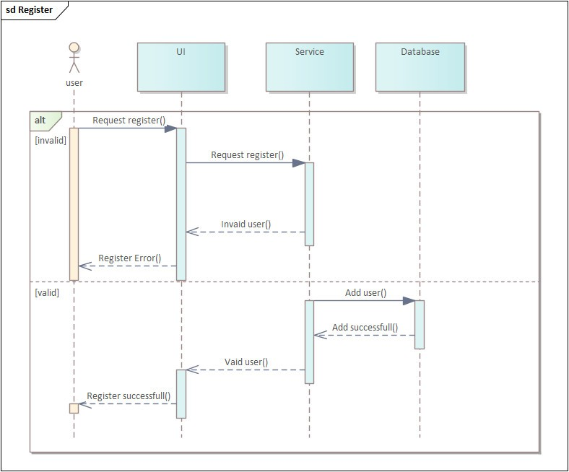

* Login

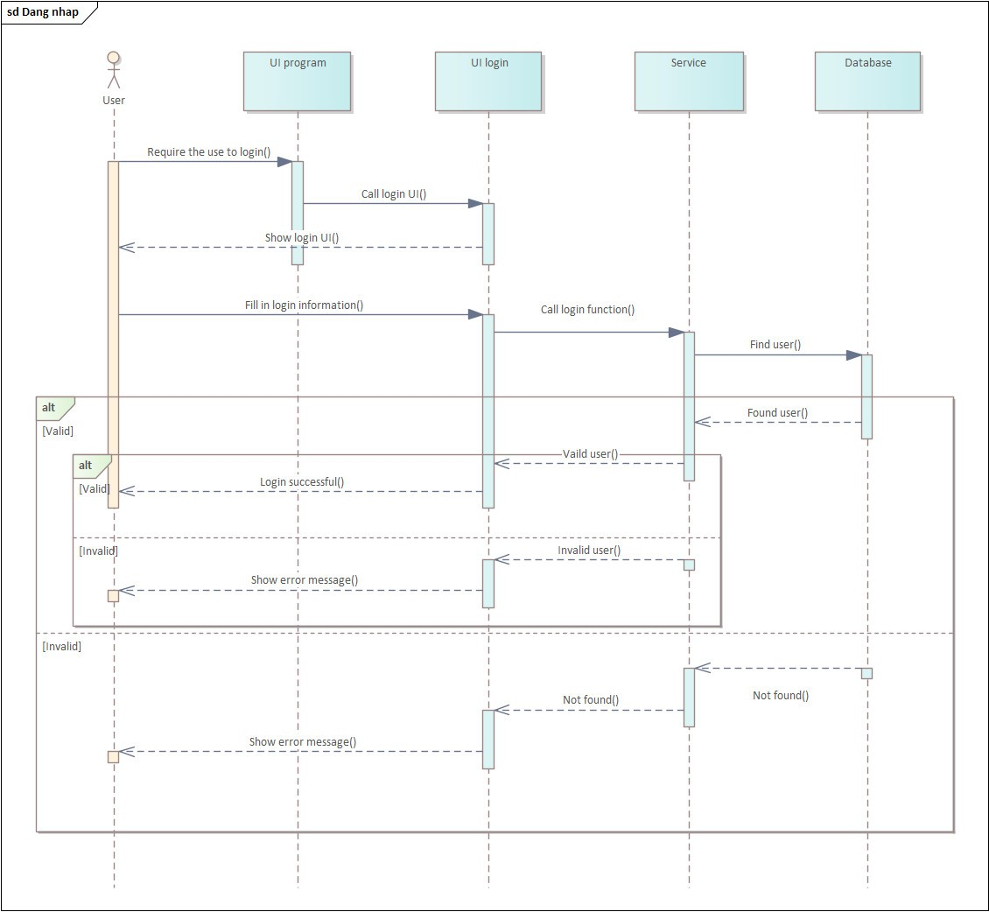

* Search products
* Add products

# **CHAPTER 4: DATABASE DESIGN**

## **4.1 Class diagram design**